ATUHEIRE EDWIN
2025/BCS/212/PS

TOURISM DATABASE_REPORT
Database Project Report

- Executive Summary
This project presents the design and implementation of a Tourism Activities Management System using a relational database. The system is developed to manage users, tourism activities, bookings, and payments efficiently. It demonstrates how databases support real-world operations through structured data storage, relationships, and query processing.

- Business Case
2.1 Application Domain
The system is designed for tourism service providers to manage activities such as safaris, hiking, and cultural experiences. It supports both administrators and customers by organizing bookings and activity information.
2.2 Benefits
- Tangible benefits: Reduced paperwork, improved data storage, and faster processing
- Intangible benefits: Better decision-making, improved customer satisfaction
2.3 Costs
• Minimal hardware requirements (computer system)
• Time spent designing and implementing the system
• Use of free/open-source database tools
2.4 User Issues
• Users require basic computer skills
• Training may be needed for beginners

2.5 Risks
• Technical risks: Data loss, system failure
• Organizational risks: Resistance to change

2.6 Limitations
• No online payment integration
• No mobile or web interface (future improvement)

- Database Design

  - Logical Design
Entities identified:
• Users
• Activities
• Bookings
• Payments
• Categories

Relationships:
• One user can make many bookings
• One activity can be booked many times
• Bookings connect users and activities
• Payments are linked to booking

The ER diagram illustrates how different entities in the system are connected:
- Users are linked to Bookings through a one-to-many relationship
- Activities are linked to Bookings to show what is being booked
- Bookings act as a bridge between users and activities
- Payments are connected to bookings to track transactions
- Categories classify activities
- 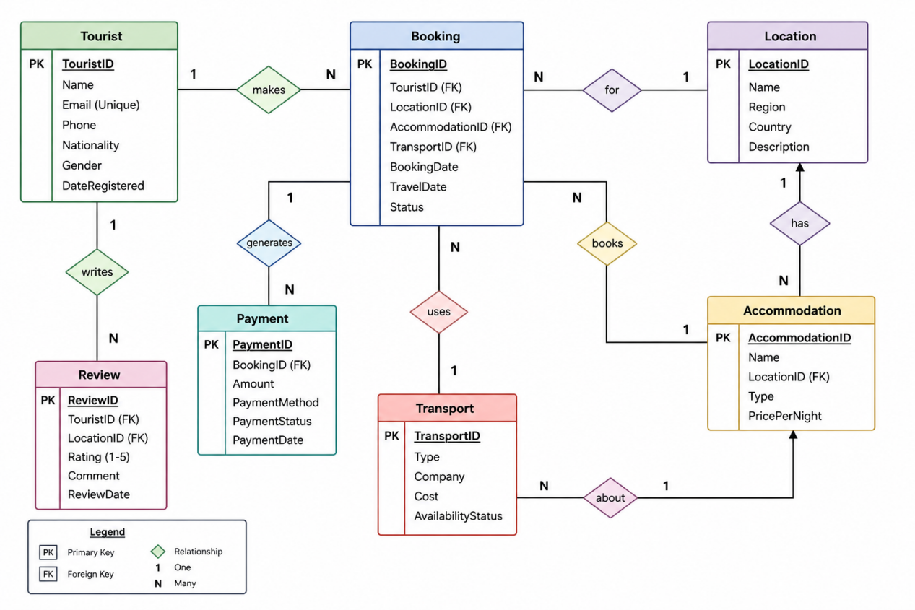
This structure ensures data consistency and supports efficient queries.

  - Physical Design
The database was implemented using MySQL.

Key Features:
- Primary keys uniquely identify records
- Foreign keys enforce relationships
- Data types ensure data accuracy

- 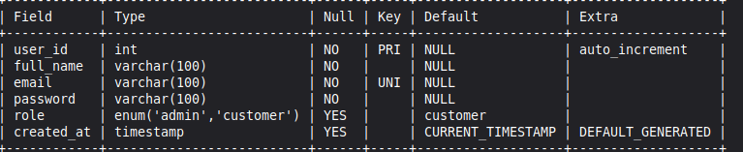
Show databases for activities
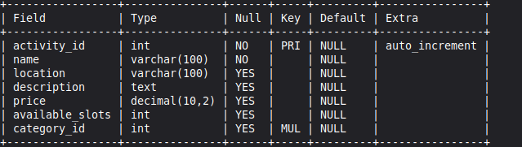
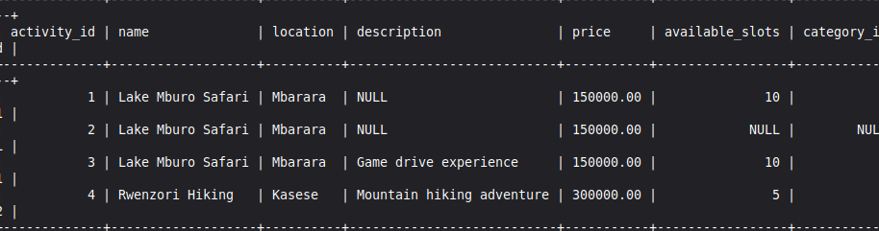
show table for users
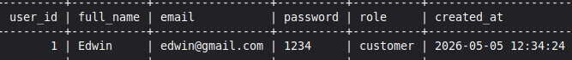

- Implementations
The system was implemented by:
• Creating database tables
• Defining relationships using foreign keys
• Inserting sample data

Tables Created:
• users
• activities
• bookings
• payments
• categories
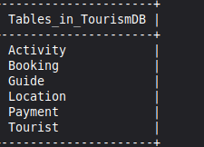

- Testing with Queries
The system was tested using different operations:

Tests Conducted:
• Viewing all records
• Checking table structure
• Testing relationships between tables
• Retrieving combined data

Database Schema
- Tourist Table

Field Name | Data Type | Constraints | Description
Tourist-ID | INT | PRIMARY KEY, AUTO_INCREMENT | Unique tourist ID
Name | VARCHAR(100) | NOT NULL | Full name
Email | VARCHAR(100) | UNIQUE, NOT NULL | Email address
Phone | VARCHAR(20) |  | Contact number
Nationality | VARCHAR(50) |  | Country of origin
Gender | VARCHAR(10) |  | Gender
Date  Registered | TIMESTAMP | DEFAULT CURRENT_TIMESTAMP | Registration date

- Location Table

Field Name | Data Type | Constraints | Description
Location-ID | INT | PRIMARY KEY, AUTO_INCREMENT | Unique location ID
Name | VARCHAR(150) | NOT NULL | Destination name
Region | VARCHAR(100) |  | Region/area
Country | VARCHAR(100) |  | Country
Description | TEXT |  | Details about location

- Accommodation Table

Field Name | Data Type | Constraints | Description
Accommodation-ID | INT | PRIMARY KEY, AUTO_INCREMENT | Unique ID
Name | VARCHAR(150) |  | Hotel/lodge name
Location-ID | INT | FOREIGN KEY → Location(Location-ID) | Linked location
Type | VARCHAR(50) |  | Hotel, lodge, etc.
PricePerNight | DECIMAL(10,2) |  | Cost per night

- Transport Table

Field Name | Data Type | Constraints | Description
Transport-ID | INT | PRIMARY KEY, AUTO_INCREMENT | Unique transport ID
Type | VARCHAR(50) |  | Bus, car, flight etc.
Company | VARCHAR(100) |  | Transport provider
Cost | DECIMAL(10,2) |  | Transport fee
AvailabilityStatus | VARCHAR(50) |  | Available/Booked

- Booking Table

Field Name | Data Type | Constraints | Description
BookingID | INT | PRIMARY KEY, AUTO_INCREMENT | Unique booking ID
TouristID | INT | FOREIGN KEY → Tourist(Tourist-ID) | Who booked
Location-ID | INT | FOREIGN KEY → Location(Location-ID) | Destination
Accommodation-ID | INT | FOREIGN KEY → Accommodation(Accommodation-ID) | Hotel booked
Transport-ID | INT | FOREIGN KEY → Transport(Transport-ID) | Transport used
Booking Date | TIMESTAMP | DEFAULT CURRENT_TIMESTAMP | Date of booking
Travel Date | DATE |  | Planned travel date
Status | VARCHAR(50) |  | Pending/Confirmed etc.

- Payment Table
Field Name | Data Type | Constraints | Description
Payment-ID | INT | PRIMARY KEY, AUTO_INCREMENT | Unique payment ID
Booking-ID | INT | FOREIGN KEY → Booking(Booking-ID) | Related booking
Amount | DECIMAL(10,2) |  | Amount paid
PaymentMethod | VARCHAR(50) |  | Cash, card, mobile
PaymentStatus | VARCHAR(50) |  | Paid/Pending/Failed
PaymentDate | TIMESTAMP | DEFAULT CURRENT_TIMESTAMP | Payment time

- Review Table

Field Name | Data Type | Constraints | Description
Review-ID | INT | PRIMARY KEY, AUTO_INCREMENT | Unique review ID
Tourist-ID | INT | FOREIGN KEY → Tourist(Tourist-ID) | Reviewer
Location-ID | INT | FOREIGN KEY → Location(Location-ID) | Reviewed place
Rating | INT | CHECK (1–5) | Rating score
Comment | TEXT |  | Feedback message
Review-Date | TIMESTAMP | DEFAULT CURRENT_TIMESTAMP | Date reviewed

User Interface
This system should be able to allow the user to enter information of different categories of people and then store them.
Below is the interface for the Admin User:
┌─────────────────────────────────────────────────────────────────────┐
│ TOURISM ACTIVITY MANAGEMENT SYSTEM │
│ ADMIN DASHBOARD │
├─────────────────────────────────────────────────────────────────────┤
│ ┌─────────────┐ ┌─────────────┐ ┌─────────────┐ ┌─────────────┐ │
│ │ 👥 USERS │ │ 🎯ACTIVITIES│ │ 👨‍🏫GUIDES │ │ 📅SCHEDULES│ │
│ │ Manage │ │ Manage │ │ Manage │ │ Manage │ │
│ │ Customers │ │ Activities │ │ Guides │ │ Schedules │ │
│ └─────────────┘ └─────────────┘ └─────────────┘ └─────────────┘ │
│ ┌─────────────┐ ┌─────────────┐ ┌─────────────┐ ┌─────────────┐ │
│ │ 📖BOOKINGS │ │ 💳PAYMENTS │ │ ⭐REVIEWS │ │ 📊REPORTS │ │
│ │ Manage │ │ Manage │ │ Manage │ │ Generate │ │
│ │ Bookings │ │ Payments │ │ Reviews │ │ Reports │ │
│ └─────────────┘ └─────────────┘ └─────────────┘ └─────────────┘ │
├─────────────────────────────────────────────────────────────────────┤
│ Quick Stats: │
│ Total Bookings: 124 │ Revenue: $5,230 │ Active Guides: 8 │
├─────────────────────────────────────────────────────────────────────┤
│ Recent Bookings: │
│ ┌───────────────────────────────────────────────────────────────┐ │
│ │ BK001 - Alice Johnson - Mountain Hiking - $45 - Confirmed │ │
│ │ BK002 - Bob Smith - Snorkeling - $60 - Confirmed │ │
│ │ BK003 - Carol Davis - City Tour - $25 - Pending │ │
│ └───────────────────────────────────────────────────────────────┘ │
│ [Add New] [Edit] [Delete] [Refresh] [Export] │
└──────────────────────────────────────────────────────────────── ─────┘
Below is the interface for Customers:
┌─────────────────────────────────────────────────────────────────────┐
│ TOURISM ACTIVITY MANAGEMENT SYSTEM │
│ CUSTOMER PORTAL │
├─────────────────────────────────────────────────────────────────────┤
│ Welcome back, [Customer Name]! │
├─────────────────────────────────────────────────────────────────────┤
│ ┌─────────────────────────────────────────────────────────────┐ │
│ │ AVAILABLE ACTIVITIES │ │
│ ├─────────────────────────────────────────────────────────────┤ │
│ │ ┌─────────────────────────────────────────────────────────┐ │ │
│ │ │ 🏔️ MOUNTAIN HIKING │ │ │
│ │ │ Duration: 4 hours | Price: $45 | Slots: 10 left │ │ │
│ │ │ [View Details] [Book Now] │ │ │
│ │ └─────────────────────────────────────────────────────────┘ │ │
│ │ ┌─────────────────────────────────────────────────────────┐ │ │
│ │ │ 🤿 SNORKELING ADVENTURE │ │ │
│ │ │ Duration: 3 hours | Price: $60 | Slots: 7 left │ │ │
│ │ │ [View Details] [Book Now] │ │ │
│ │ └─────────────────────────────────────────────────────────┘ │ │
│ │ ┌─────────────────────────────────────────────────────────┐ │ │
│ │ │ 🏙️ CITY WALKING TOUR │ │ │
│ │ │ Duration: 2 hours | Price: $25 | Slots: 20 left │ │ │
│ │ │ [View Details] [Book Now] │ │ │
│ │ └─────────────────────────────────────────────────────────┘ │ │
│ └─────────────────────────────────────────────────────────────┘ │
├─────────────────────────────────────────────────────────────────────┤
│ [My Bookings] [My Reviews] [Profile Settings] [Logout] │
└─────────────────────────────────────────────────────────────────────┘
Below is the interface for the Guide:
┌─────────────────────────────────────────────────────────────────────┐
│ TOURISM ACTIVITY MANAGEMENT SYSTEM │
│ GUIDE PORTAL │
├─────────────────────────────────────────────────────────────────────┤
│ Welcome, [Guide Name]! License: LIC123 │
├─────────────────────────────────────────────────────────────────────┤
│ MY SCHEDULE FOR THIS WEEK: │
│ ┌─────────────────────────────────────────────────────────────┐ │
│ │ DATE │ ACTIVITY │ TIME │ CUSTOMERS │ STATUS│ │
│ ├───────────┼────────────────────┼─────────┼───────────┼───────┤ │
│ │ 2026-06-15│ Mountain Hiking │ 09:00 AM │ 2 │ Upcoming│ │
│ │ 2026-06-17│ City Walking Tour │ 02:00 PM │ 1 │ Upcoming│ │
│ │ 2026-06-20│ Snorkeling Advent. │ 10:30 AM │ 4 │ Upcoming│ │
│ └─────────────────────────────────────────────────────────────┘ │
├─────────────────────────────────────────────────────────────────────┤
│ TODAY'S TASKS: │
│ ✓ Check equipment inventory │
│ ✓ Arrive 30 minutes before start time │
│ ✓ Take attendance │
│ ✓ Collect customer feedback │
├─────────────────────────────────────────────────────────────────────┤
│ [Mark Attendance] [Report Issue] [View Earnings] [Logout] │
└─────────────────────────────────────────────────────────────────────┘

5. Conclusion
The Tourism Activity Management System enhances efficiency in tourism organizations by recording information for customers, activities, guides, schedules, bookings, and payments. This system is designed with optimized queries, constraints, and indexes for efficiency, which facilitates quick access to information, thus benefiting many tourism stakeholders including tour operators, customers, and guides.

6. Bibliography

MySQL Documentation: https://dev.mysql.com/doc/
A Practical Approach to Design, Implementation, and Management Sixth edition by Thomas Connolly & Carolyn BeggEclipse Foundation. (2025). Eclipse IDE for Java Developers. Retrieved from https://www.eclipse.org/.Database design tutorials from W3SchoolTourism management systems comparison: Fare Harbor, Peek Pro, Check-front

